English Grammar: Fears and Phobias

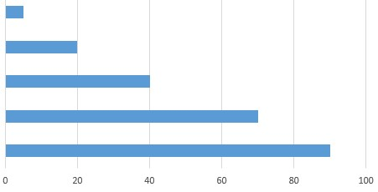
Fears & Worries I’m concerned about my son’s school grades.
I’m worried about my mother’s health.
I’m afraid of dogs. / I’m wary of dogs.
I’m scared of injections.
I’m scared to death of cemeteries!

Phobias I suffer from arachnophobia.

I suffer from acrophobia.

I suffer from agoraphobia.

I suffer from claustrophobia.
I suffer from aerophobia.

A list of phobias: https://www.fearof.net/
(hippopotomonstrosesquipedaliophobia – the fear of long words!)
Complete the following sentences for you, using the correct prepositions:
1. I’m afraid ________ ________________________.
2. I’m scared ________ ________________________.
3. I’m worried ________ ________________________.
4. I’m concerned ________ ________________________.
5. I’m scared to death ________ ________________________.
6. I suffer ________ ________________________.

Other language:
I have a fear of flying.
Spiders scare me.
Scorpions frighten me.
I’m fearless - nothing scares me.
I’m brave - snakes don’t scare me.

